Automated Batch Reporting

Reports and Utilities can be configured to run automatically any time of the day and as often as desired. Only programs with the YELLOW toggle labeled run in Batch can be automated. For example, the H-L Last Year vs This Year Report has this toggle box which will save the parameters on the screen to the N-R-1 Batch File. For example, the report listed below will start on 06/19/2014, for all customers and for Sales Rep 001to 001, etc. Therefore, the automated batch program will run with the same parameters selected below. Another batch can be setup for another sales rep so that each report will be printed on separate pages. To change the starting date, the Batch File can be modified.

Sales History – Last Year vs This Year

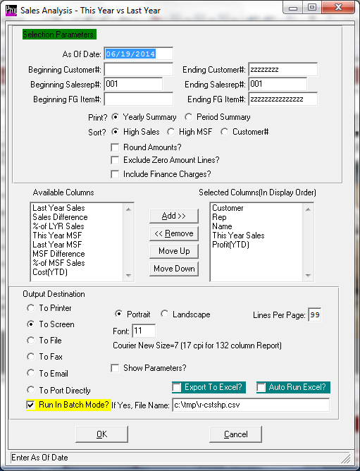

Automated Batch Reporting

The N-R-1 Report file stores the print parameter selections that will print. The batch report can be copied and then changed for another sales representative. Likewise, the data can be updated of that the reports print parameters can be modified each day, week or month. For example, the sales report below will need to be updated at the beginning of each month to the 1st day of the month.

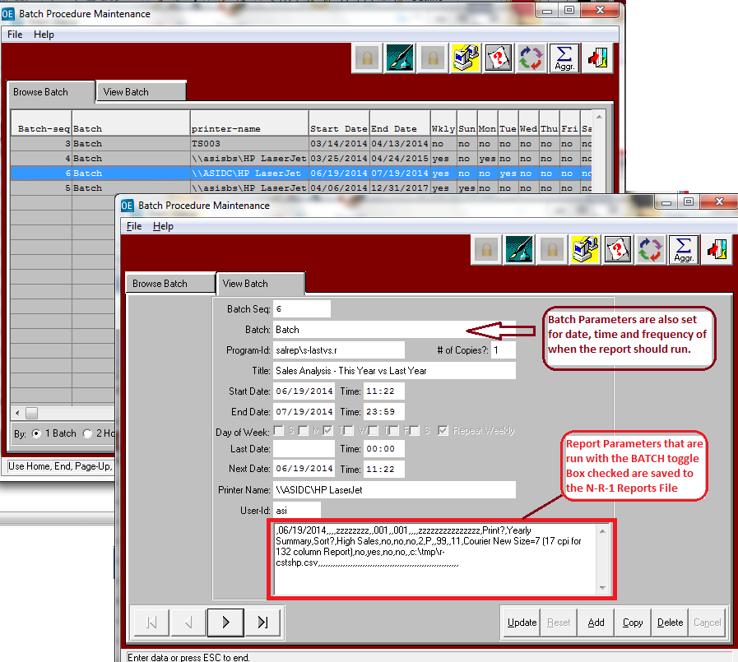

Automated Batch Reporting

The System Menu works in conjunction with the N-R-1 Report File to automate the report.  
The frequency of the report, the days of the week to print and how often to report the report.

Currently, Batch Reporting can be added to any report or utility in a couple of hours of programming. Currently, N-Y, N-F-10, O-R-5, O-R-16,

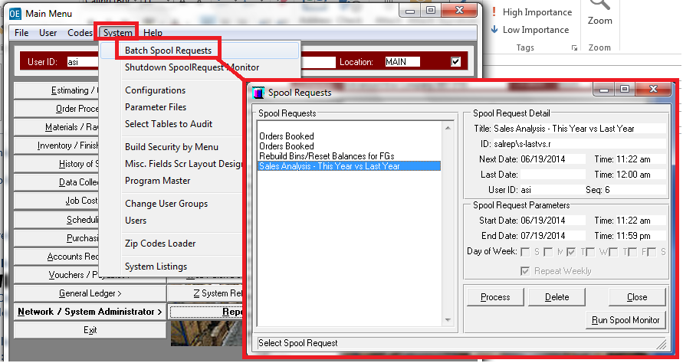

Automated Batch Reporting

Sales History - With Dollars per MSF Totals by Sales Rep Report.

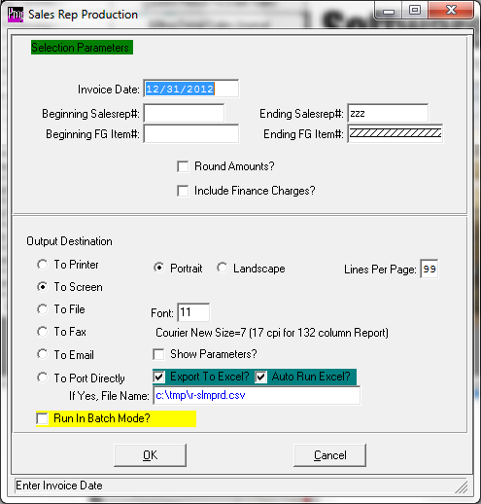

Automated Batch Reporting

Orders Booked Report

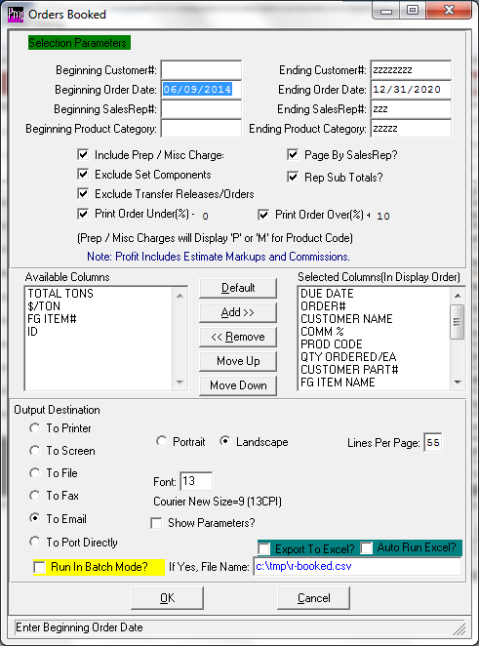

Automated Batch Reporting

Open Orders Booked Report

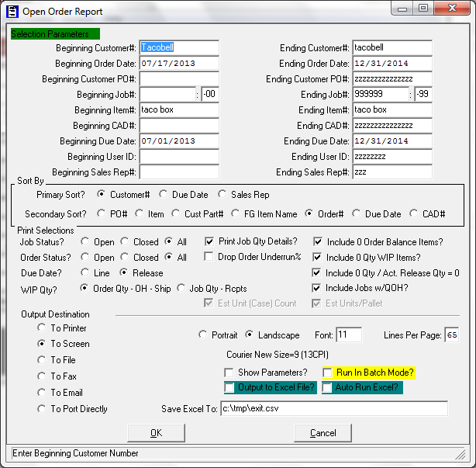

Automated Batch Reporting

**System Admin – File Cleanup – FG Rebuild Bins / Reset Balances**

This is an excellent report to run at night as the system rebuilds the finished goods balances in chronological order by date of posting of receipts, shipments, physical counts and adjustments. Running this report during the day can affect the overall response time, therefore this is a good utility to run every night in an automated batch process. ASI recommends to UNCHECK the Delete Zero Quantity Bins as the I-F-1 Bins Tab already eliminates this from displaying. Please note, to speed this Utility, an option is also available to recalculate only ACTIVE item and the N-R- Util/Utils program called SetFGIA can be run to set finished goods to inactive based on inactivity.

